DRAW FLOWCHART + WRITE C CODE

- A leading newspaper pays all their freelance writers at a rate of Tk. 500 per published article. Draw the flowchart for a program that will read the number of published articles for one writer, and print the total monthly fees for that writer.

- Write a flowchart and a program for finding area of a rectangle given height and width.

- Given number of courses, credits in each course and per credit cost, find how much a student have to pay for a particular semester.

- Ask an user to input a value of Q and find the value of P
Suppose the following expressions are used to calculate the values of P for different values of Q:
P = 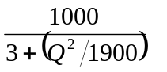
- Write a flowchart that reads the values for the three sides x, y, and z of a triangle, and then calculates its area. The area is calculated as follows: 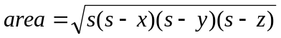
where s is 